**Lab Assignment: 08**

**Object:** To draw the **Class Diagram** for ***Hotel Management.***

**Introduction**:

Class diagram is a static diagram. It represents the static view of an application. Class diagram is not only used for visualizing, describing, and documenting different aspects of a system but also for constructing executable code of the software application.

Class diagrams provide a structural view of systems. It captures the static structure of Object-Oriented systems, or how they are structured rather than how they behave.

Class diagrams support architectural design. It represents the basics of Object-Oriented systems. They identify what classes there are, how they interrelate and how they interact.

**Class Diagrams at a Glance:**

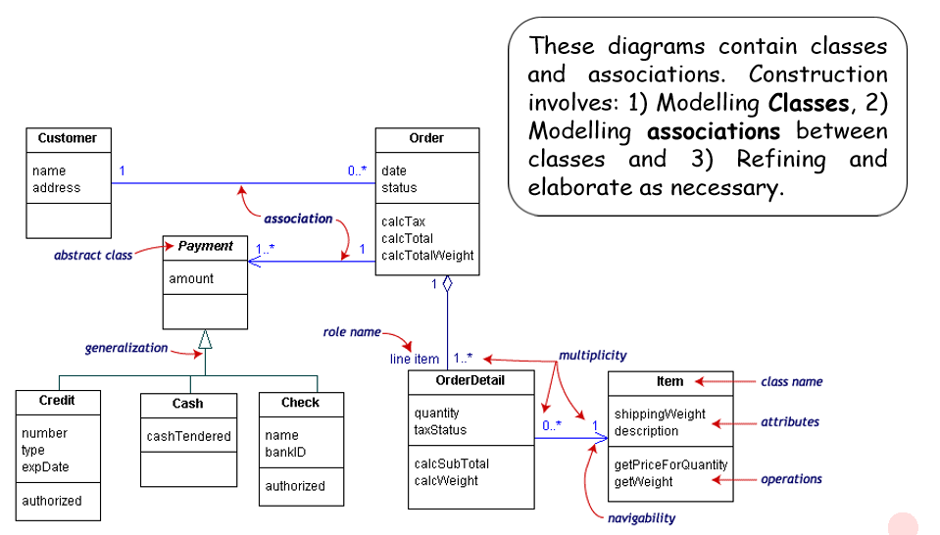

**Where to Use Class Diagrams?**

Class diagram clearly shows the mapping with object-oriented languages such as Java, C++, etc. From practical experience, class diagram is generally used for construction purpose.

In short, class diagrams are used for −

* Showing the collaboration among the elements of the static view.
* Describing the functionalities performed by the system.
* Construction of software applications using object-oriented languages.

**Class Diagrams in the Life Cycle:**

* They can be used throughout the development life cycle.
* Class diagram carry different information depending on the phase of the development process and the level of detail being considered.
* The contents of a class diagram will reflect this change in emphasis during the development process.

**Class Diagram Rationale:**

* Desirable to build systems quickly and cheaply (and to meet requirements)
* Desirable to make the system easy to maintain and modify.